**Integrated Jenkins with SSH Keys:-**

Step1: first we login into the Jenkins home page with your localhost and port number **localhost:8181**

**Step 2:Create SSH keys in your Jenkins EC2 instance**

ssh-keygen

enter four times. this will create keys in .ssh folder.

Copy and paste the public key

**sudo cat ~/.ssh/id_rsa.pub**

step3: **Add public Keys into your respective GitHub**

Add public keys into your Repository--> settings--> Deploy keys section

Step4: **Add Private Keys in Jenkins Master**

Login Jenkins. Go to Manage Jenkins. click on Credentials

[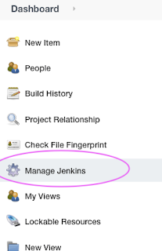](https://1.bp.blogspot.com/-NPS_IeMfkaY/YNtHBvBZP8I/AAAAAAAADfg/Xd5SXoeSasYv97WwjHsth_Vs2dWYfpIEQCLcBGAsYHQ/s435/Screen%2BShot%2B2021-06-29%2Bat%2B11.06.35%2BAM.png)

[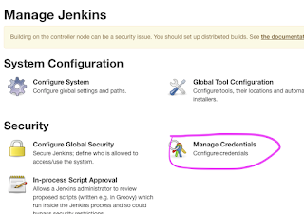](https://1.bp.blogspot.com/-YtqQQq3vuSQ/YNtHBrcUSfI/AAAAAAAADfc/uJzX6VfR_58wTGcob9mNglH6N4imlFD2ACLcBGAsYHQ/s736/Screen%2BShot%2B2021-06-29%2Bat%2B11.06.41%2BAM.png)

Click on Jenkins

[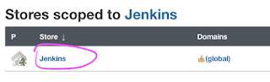](https://1.bp.blogspot.com/-HXdbmCWsBsk/YNtH0DRJG2I/AAAAAAAADf8/bHeUzPH3-AMqgQwi3UOMjOdEvMA13j5NwCLcBGAsYHQ/s531/Screen%2BShot%2B2021-06-29%2Bat%2B11.17.29%2BAM.png)

Click on Global Credentials

[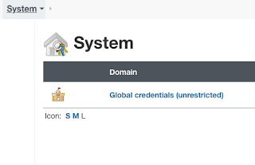](https://1.bp.blogspot.com/-TXAM5PjoyJk/YNtIJ4c6zjI/AAAAAAAADgI/p2MewwO89s4Q_Mmyp1KtjAgJBN8GBKxJgCLcBGAsYHQ/s478/Screen%2BShot%2B2021-06-29%2Bat%2B11.19.01%2BAM.png)

Click on Add Credentials

[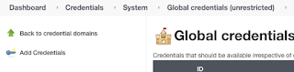](https://1.bp.blogspot.com/-X-h_BFiE2cE/YNtHP5r4gTI/AAAAAAAADfk/Qa6zXw7KwKsnbL3hr6lXEeM8OzEneM1VwCLcBGAsYHQ/s669/Screen%2BShot%2B2021-06-29%2Bat%2B11.11.04%2BAM.png)

Choose SSH username with private key

[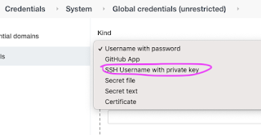](https://1.bp.blogspot.com/-ps8YBrrZoWw/YNtIoS6hufI/AAAAAAAADgc/QnJ38SH1FVQVFGZo0lVcwdUhiRU7M5kLwCLcBGAsYHQ/s562/Screen%2BShot%2B2021-06-29%2Bat%2B11.11.20%2BAM.png)

Choose SSH username with private key  
username can be anything  
Click on enter directly under private key option and Click Add

[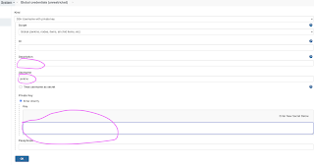](https://1.bp.blogspot.com/-QchhvJj07uo/YNtJvh4ieVI/AAAAAAAADgs/NfG3izdHiosMHPaR9RYHsUXKPe2vJk_TgCLcBGAsYHQ/s1626/Screen%2BShot%2B2021-06-29%2Bat%2B11.25.39%2BAM.png)

Copy and paste **private key(not public key)**of your from Jenkins instance. command is below:  
**sudo cat ~/.ssh/id_rsa**  
  
copy the content of whole output from above command.

Click OK to save.

Now go to any Jenkins Job, you can choose this option for checking out from GitHub. Make sure you enter SSH url not https url.

Step 5: Click on BuildNow Button and show the status.

